GENERATOR

1. Create Generator function in Python.

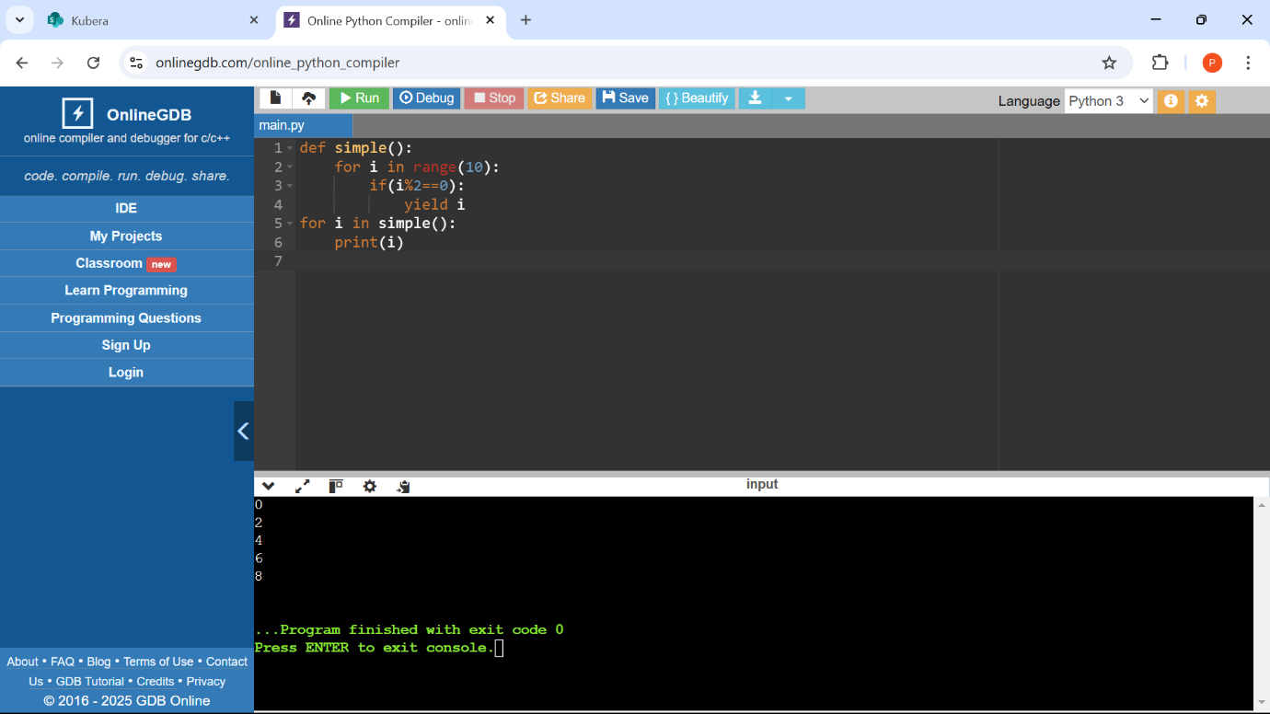

2. Use the multiple yield statement in the generator function.

3. List comprehension has returned the list of cube of elements whereas

generator expression has returned the reference of calculated value.

4. How can we retrieve values from a generator without using a for loop, and what function can be used to get the next value from the generator object?

5. Write a program to print the table of the given number using the generator.

6. Using the sys.getsizeof() function.

7. illustrate how a generator can produce an infinite sequence without exhausting memory

